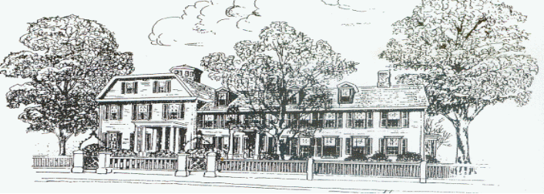
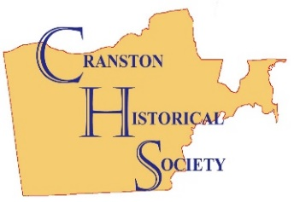

CHS Newsletter
Spring/Summer 2026

April 21 - 7:00 pm CHS Membership Meeting
Topic: General Greene: A Biography of the American Revolution
Presented by Gerald Carbone, Author

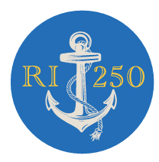
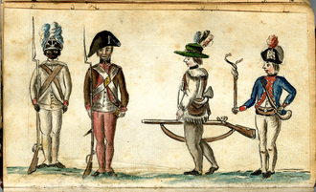

Up Coming Events
April 26 – American Girl Doll Tea 1 to 3pm
May 15 – Tour with Tea 4pm
June 18 - Joy Homestead Colonial Family Day as part of Cranston’s America 250th Celebration 4pm
July 24 - Summer Tour with Tea 4pm
August 25 – A Taste of Cranston 5pm
Sept. 25 - Fall Tour with Tea 4pm
Oct. 23 Ghost Party with Jared the Mentalist 7pm

BOARD Of DIRECTORS

Linda Casey (Hospitality)
James Hall (Curator)
John Hill (Cranston Historical Cemeteries)
Fred Joslyn (Legal Advisor)
Gregg Mierka (Property Management)
Mary Mierka (Events and Rentals)
Sandra Moyer (Endowment)
John O'Leary (Nominations)
Barbara Polichetti (Publicity)
Grace Swinski (Fundraising)

Director at Large
Ann Sasso
John Donegan

OFFICERS

Sandra Moyer
President

John O’Leary
Vice President

Mary Mierka
Secretary

Tristan Poirier
Treasurer

The Cranston Historical Society's mission is to protect, document, interpret and expand understanding of Cranston history.
1351 Cranston Street ~ Cranston, RI 02920 (401) 944-9226
facebook.com/cranstonhistoricalsociety www.cranstonhistory.org
email: cranston.historical.society@gmail.com

The printing of all CHS Newsletters is done by All The Answers, Warwick
Mailing, Printing & Design Services

President’s Message

President’s Message
By Sandra Moyer

2026 promises to be an exciting year for the Cranston Historical Society. One of the things that has happened so far this year is that we have an updated and expanded website. Please check out cranstonhistory.org to learn about some of the events that have taken place in the Society recently and to keep abreast of our future plans. We also continue to update our
Facebook page and ask that you friend us and share our posts with your friends.
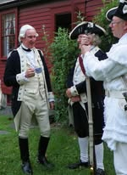
Our social media is especially important this year because it is the 250th Anniversary Celebration of our nation’s birth and Cranston has many events planned. (see page 4 for a calendar of events). Since our organization’s role is promoting the history of our city, we are doing all we can to make this year memorable.
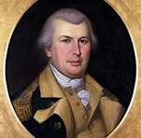
One of the biggest events will be the Colonial Family Day held on June 18th at the Joy Homestead. We’ve been celebrating this day with a Rochambeau Strawberry Tea for many decades but this year it will have an expanded food menu, games of the era, storytelling and a reenactment of the Joy children greeting the French soldiers as they marched by their house on the way to the Battle of Yorktown.
To kick off this year, our speaker for our April meeting is Gerald Carbone, noted biographer of Nathanael Greene, who will speak on this famous Rhode Islander who became George Washington’s favorite general and had a big role in winning the American Revolution. He served as quartermaster for procuring the army’s supplies. Later he led the southern campaign in the Carolinas.


This newsletter continues the theme of our country’s beginnings. Mary Mierka’s column tells how important tea was in creating animosity between the 13 colonies and England. Jim Hall recounts how Cranston’s Pawtuxet Neck was the site of a fort built to guard Narragansett Bay. In my article on the Liberty Tree, you will learn how such trees became symbols of Colonial defiance against the King and you can discover how your family can receive a free tree professionally planted in your own yard to commemorate this year for decades to come.

Calendar of 250th Anniversary Events

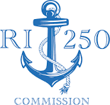
The Cranston Historical Society is working closely with Mary Greim –Gallo, the Chairperson of the Cranston 250th Commission. We were the sponsoring organization listed on the grant that is funding many of Cranston’s celebratory activities. Three of our board members are on the city’s 250th commission and several of the activities are taking place on our properties.

This is the calendar of the activities that have been planned in our city.

April 11 11 am Lacemaking Demonstration CPL – Central Branch

April 21 7 pm Presentation on General Nathanael
Greene by Gerald Carbone Gov. Sprague Mansion

May 6 4 pm Planting of the Liberty Tree Cranston City Hall

May 30 11 am Presentation on Revolutionary CPL – Wm. Hall Branch
ancestry and viewing of state
documents

June TBA Concert by the Lafayette Band Itri Square

June 18 4 pm Colonial Family Day commemorating Joy Homestead
the day that General Rochambeau
marched through Cranston to meet
General Washington at Yorktown

June 23 6 pm Presentation by Dirty Blue Shirts on the CPL – Central Branch clothes worn during the American
Revolution

TBA Award ceremony for student winners Gov. Sprague Mansion
of the art and writing contests

Membership News
In Memoriam
Anne DelSanto Ravencroft

Membership Dues — Reminder
Your 2026-2027 Membership Dues are Due!

NEW -- Email Updates: To receive email communication, please send your contact info to: cranston.historical.society@gmail.com
Please support our Other Business Members and Donors:
All The Answers, Inc.-Warwick, Mailing & Printing Services alltheanswersinc.com
PPA, LLP-Certified Public Accounts info@ppallp.com
Rhode Island Civil War Round Table-RIs premier Civil War discussion group ricwrt.com
Rhode Island Dental Arts-Cranston, All dental services ridentists.com
EMC (Energy Management & Control Services)-Cranston, providers of
building control/energy & integrated facility management systems emccontrols.net
Forest Hills Nurseries Inc.-Cranston, Retail/Wholesale plants/nursery foresthillsnurseries.com
After 5 Party Rentals-Rumford james@after5partyrentals.com
Home Depot-Johnston Lowes-Cranston
Goldstar Landscaping & Irrigation-No. Prov. rmacari@cox,net
Tasca Auto Group-Pontiac Ave.-Cranston tasca.com
North Eastern Tree Services-Cranston northeasterntree.com
JTN Landscaping Services-Central Falls jtnlandscapingservices@gmail.com
Rotary Club of Cranston rotaryclubofcranston.org
Vonsol Construction Management-Cranston vonsolpartners.com
Thank You Social Media Committee
CHS Has A New Website!

Sandra Moyer; Mary & Gregg Mierka; Mindy Souvannlay; Barbara Polichetti; John Hill; John Donegan; Ron Barnes;
Jim Hall & Tom Worthington
- Holiday Open Houses DECEMBER 7, 2025 --Thank You Event Sponsors
Greetings from Cranston Mayor Kenneth Hopkins & Secretary State Gregg Amore
Outside Tree Lighting: Special Guests/Ward 3 Councilman Andy Andujar. Bain Choir/Band
Event Sponsors: Brady Sullivan Properties; Cranston Municipal Employees Credit Union; Atty Frank Lombardi; Former City Mayor Michael Traficante; Saccoccio & Associates Architects; Cranston Fire Fighters Local 1363; Taco Comfort Solutions; Ward 3 Councilman Andy Andujar; Energy Management & Control Services; Tasca Automotive Group

A Hearty Acknowledgement for Your Support at A Taste of Cranston
CHS Committee Members: John O’Leary, Sandra Moyer, John Donegan, Grace Swinski, Linda Casey, Ann Sasso, John Hill, Gregg & Mary Mierka, Barbara Polichetti, Jim Hall, Paul McAuley
City of Cranston: Mayor Kenneth Hopkins and Staff; City Intern JP Vallot; Department of Public Works; Stephen Craddock-Ex. Dir. Dept. Senior Services; O’Leary Family; A Taste of Cranston Banner -- Christopher Paplauskas. Volunteers: Ben Caito and Boy Scout Troop #66; Swinski Family: Grace, Joe, Ivy; Margaret Noel, Jane Jellison; Andrea & David Champagne; Lindsey Angell – Created CHS Aprons for this event; Western Cranston Garden Club – Volunteers & Table arrangements; Cranston Rotary including: Roy Evens, Adrian Beaulieu, Dina Campbell, Tom Glasgow; Gavin Corriveau-St. Mary’s; Christina & Ralph Walton; Denise Moretti-Foggo; Coca Cola Beverages; Northeast; Falvey Linen; Cooking Demonstration by Cranston Chef Jesse Tate; Stop & Shop; Shaw’s; Art in Ice/Ocean State Ice

First Annual “A Taste of Cranston” on August 26th
13 Cranston Restaurants Participated
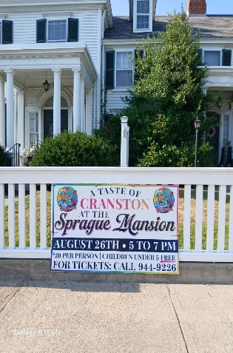
Fall Happenings
Chef Jesse
Demonstration
Edgewood Cheese Shop

Twin Oaks
Restaurant

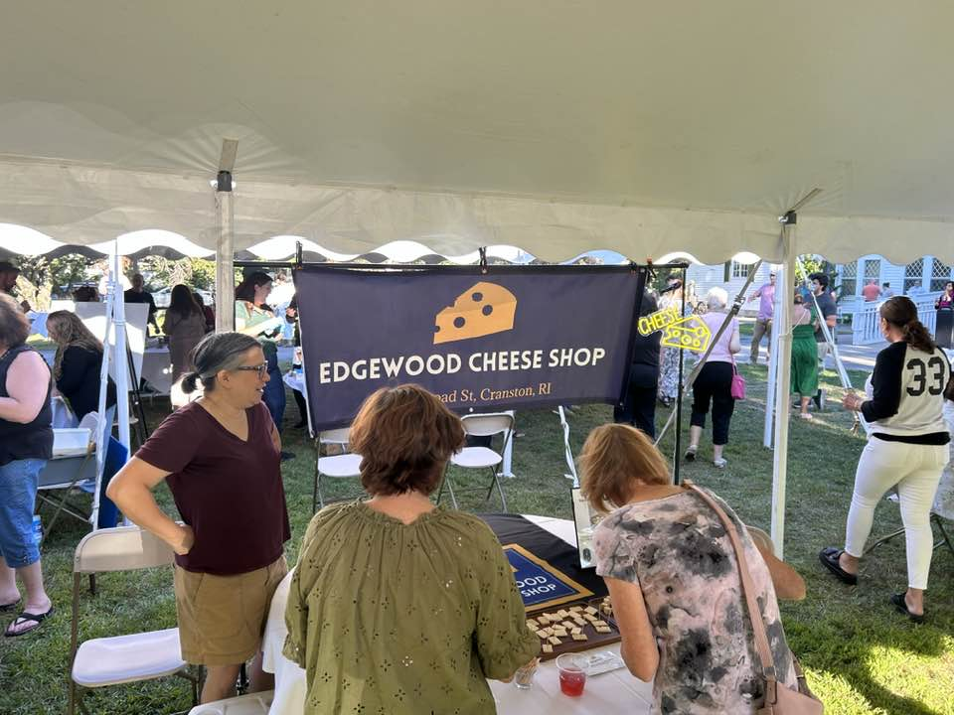
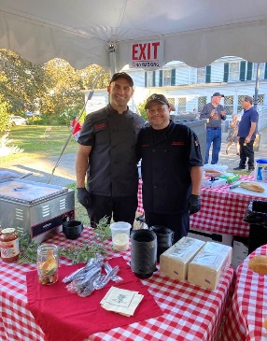
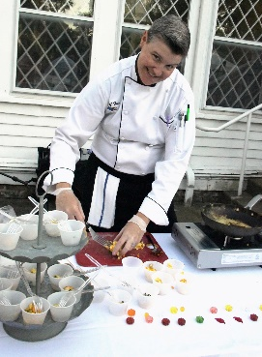
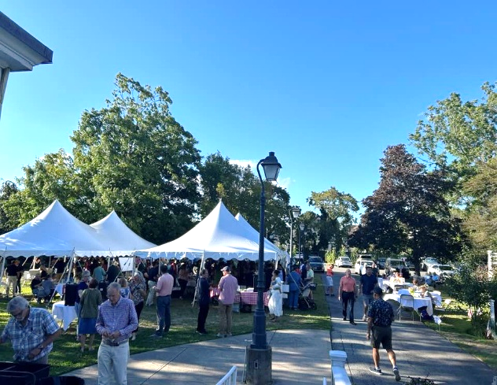
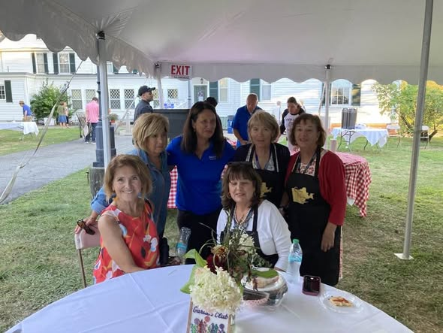
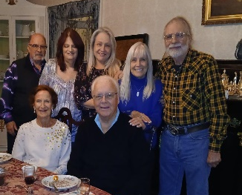
Thanks to the Western Cranston Garden Club for their help!
Silent Auction Winners Private Tour w/Tea

Charlie the Butler Ghost Party with Jared the Mentalist on Oct. 24th
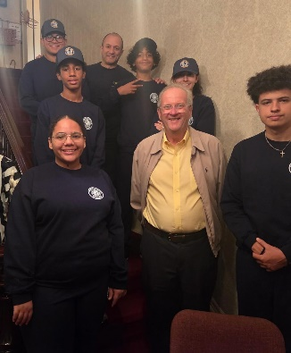
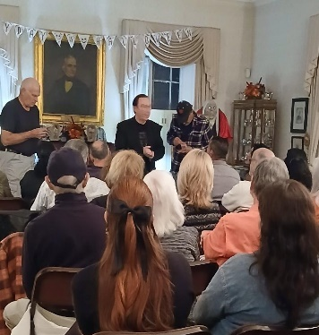
Cranston Police Cadets assist at Oct. Ghost Party with Mayor O’Leary.
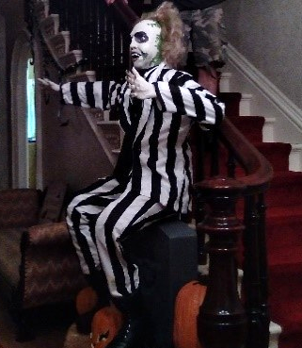

Holiday Happenings
Christmas Open House on December 7th

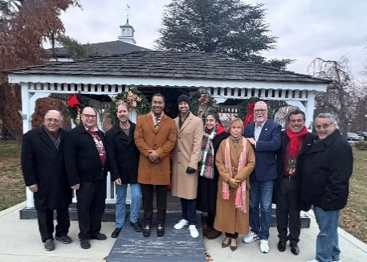
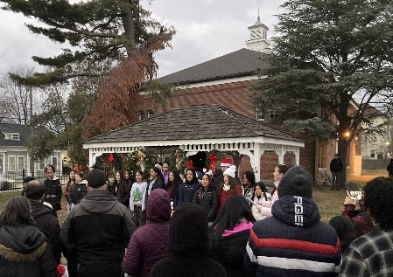
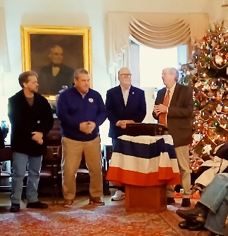

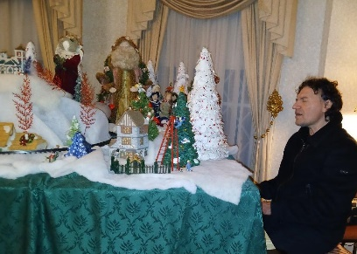
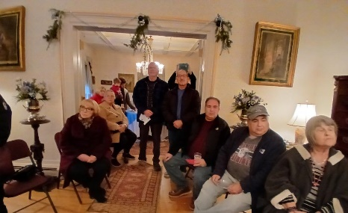
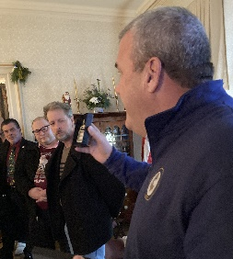
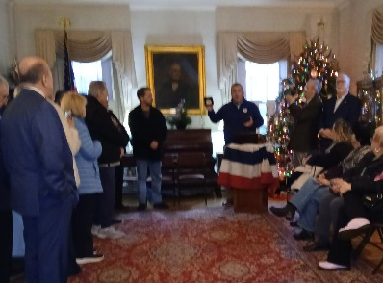

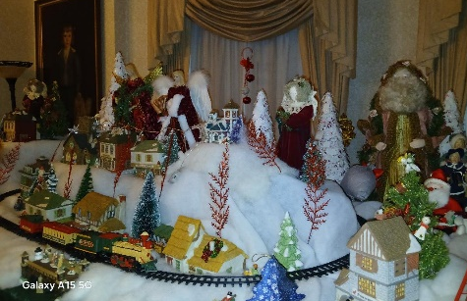
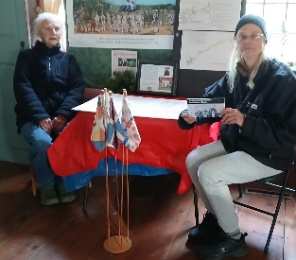
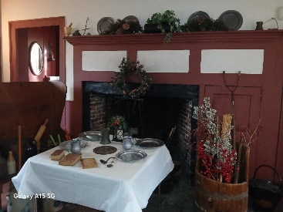
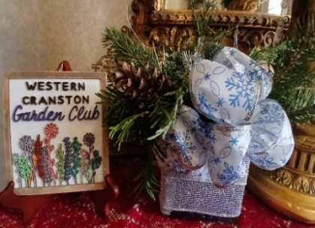

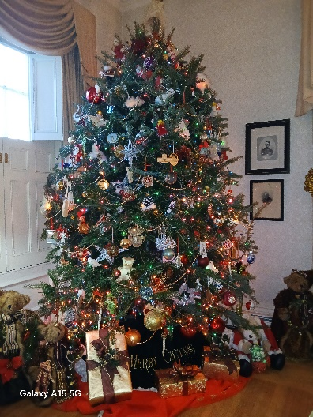
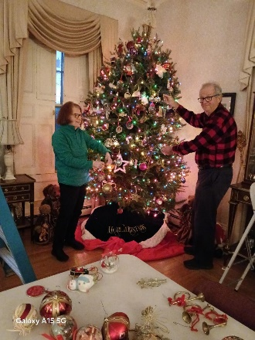
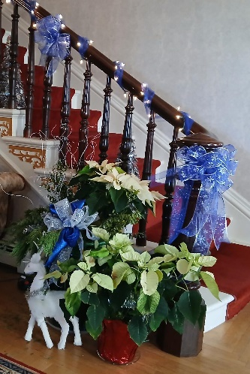

Lifestyles

Lifestyles

The Liberty Tree
By Sandra Moyer

The original Liberty Tree was an elm tree that was planted in 1646 near the Boston Common. In August of 1765, when the tree was already over a hundred years old, the Patriots in Boston held their first act of defiance against British rule around the tree.
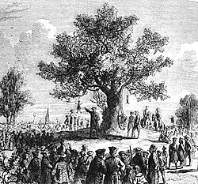
Earlier in that year, the British Parliament had passed the Stamp Act which required that a tax stamp, which had to be bought by the colonists, be placed on all legal documents, permits, commercial contracts, newspapers, pamphlets, and playing cards. The colonists rose in protest and in Boston, on August 14, 1765, a large crowd gathered under this tree near Boston Commons and hung effigies of the local tax collectors from its branches.

A year later, the Stamp Act was repealed and the townspeople gathered to celebrate under the Liberty Tree that was bedecked with flags, streamers and lanterns. The idea of Liberty Trees spread and communities from Newport, RI to Charleston, SC named their own trees, making them a symbol of the American Revolution. Unfortunately, Loyalists to the British government cut down Boston’s Liberty Tree in August 1775 after the American Revolution started. However, the stump remained and was revered by Bostonians for many years.

As part of Rhode Island’s celebration of the 250th Anniversary of the start of our nation, each town and city is planning on planting their own Liberty Tree, a red maple which is our state tree. Cranston’s Liberty Tree will be planted on the grounds of City Hall at 4 pm on Wednesday, May 6th.


If you would like your family to have its own Liberty tree, the city of Cranston is providing free 5 to 6 feet trees to interested residents as it does every year. The trees will be planted in your front yard by professional nurseries at no charge. For more information, email the Cranston Tree Group at cranstontree@gmail or call 401-941-1264. Application forms for your family’s free tree can be downloaded at westbaylandtrust.org/cranstontree.

of Long Ago

Ladies of Rhode Island Host Own Tea Party on March 2, 1775
By Mary Mierka
This plaque erected in 1894 by the SAR/DAR reads:
Near this spot the men and women of Providence showed their resistance to the unfair taxation by burning British Taxed tea on the night of March 2, 1775.

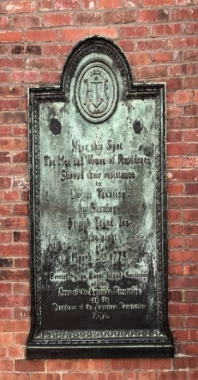
During the mid-1770s, there were many Tea Parties protesting British tea taxes all along the Eastern Coast from Maine to Charleston, South Carolina. South Carolina was actually the first state to protest the tea tax on December 3, 1773. Then on December 16, 1773 in what was known as the Boston Tea Party, colonists dumped 340 chests in Boston Harbor, which was the equivalent of 18,523,000 cups of tea.

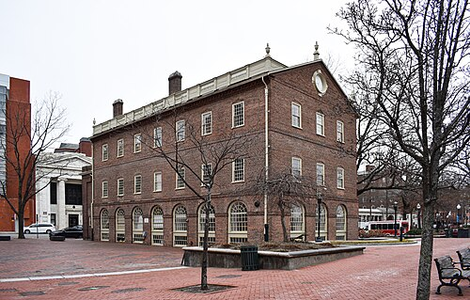
More than a year later on March 2, 1775, ladies of Rhode Island hosted a tea burning party to show their solidarity and support for the ladies in Boston. It occurred in front of the Market House in Market Square on North Main Street at the foot of College Hill.

Assisting were members of the Sons of Liberty who helped ignite tar fire pits and “lampblacked” (painted with black tar) any building fronts showing the word “tea”. They burned 300 pounds (about 68,000 to 70,000 cups of tea) of bricked teas that included five pricey, luxury teas from the Chinese Wuyi and Anhui regions. Popular among the Colonists were the Bohea and Hyson teas. Bohea black tea has a complex, aromatic & invigorating smoky flavor while Hyson green tea has a sweet, floral and earthy flavor. Most of the tea was sold in bulk as compressed bricks.

Most tea was imported by the East India Company to which the British gave major tax cuts, angering Colonists. Independent shipping companies and individuals had to pay extremely high taxes. If the order was not from a reputable tea merchant, one could receive an inferior tea (referred to as ‘smouch’) combining a variety of odd plants mixed with a speck of the black tea and even dung.
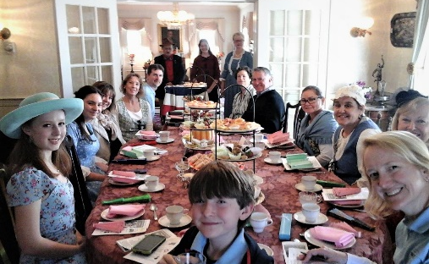
Come to one of our special America 250th Tour with Teas to sample Bohea tea and feel like a wealthy Colonist savoring these special teas from England. We promise it’ll be the real thing! Dates are 5/14, 7/24 and 9/25.

Cranston’s Own Revolutionary Fort on Pawtuxet Neck
Curator’s
By Jim Hall, Curator
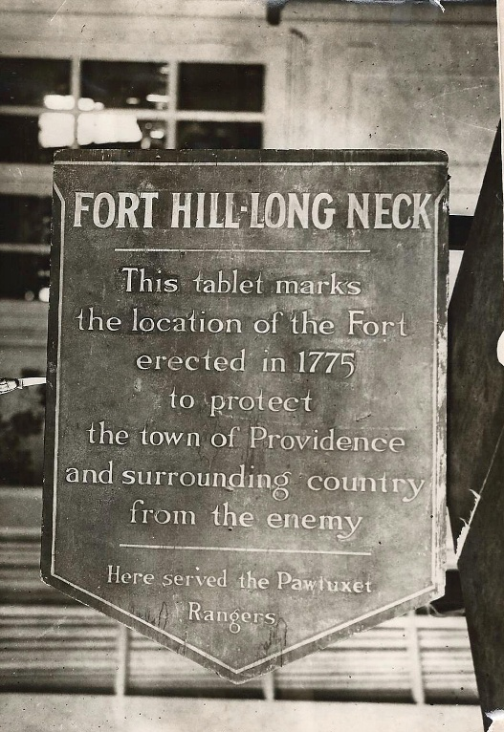
In 1954, a commemorative tablet marking the site of a Revolutionary War fort was installed on Fort Avenue in Pawtuxet, recalling a defensive work that once protected the Providence area during the early days of the American Revolution. A photographic print preserved by Dr. and Mrs. W. J. Butler of 52 Fort Street in Pawtuxet shows the tablet that was mounted to a tree in their yard on the Fort Avenue side of the property. Though modest in appearance, the plaque commemorates an important but now largely forgotten military installation: Fort Hill on Long Neck.
The inscription reads:
“Fort Hill – Long Neck. This tablet marks the location of the fort erected in 1775 to protect the town of Providence and surrounding country from the enemy. Here served the Pawtuxet Rangers.”
The fort itself was constructed on October 17, 1775, only a few months after the outbreak of the Revolutionary War. At that time the threat of British naval attack along the Rhode Island coast was very real. The colony’s leadership began strengthening coastal defenses and establishing small fortifications at strategic points along Narragansett Bay.
Fort Hill stood on land owned by Captain Remington of Pawtuxet, on what was then known as Pawtuxet Neck, an area commanding an excellent view of the bay. The site was chosen with care. According to historical descriptions, the fort extended from shore to shore across the neck, effectively controlling access to the peninsula. On the bay side, the land dropped sharply from the high bluff to the water below—almost a sheer descent—which made the position naturally defensible.
Inside the fortification stood a small guardhouse measuring twelve by eight feet, providing shelter for the soldiers stationed there. The fort’s primary armament consisted of two 18-pounder cannon, powerful guns capable of firing iron shot across the water toward the East Providence shoreline. From this commanding vantage point, defenders could monitor and potentially engage hostile vessels attempting to move up the bay toward Providence

Corner

Corner

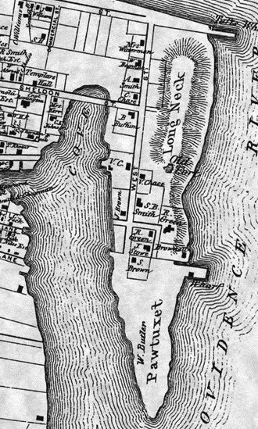
The men who served here were known as the Pawtuxet Rangers, a local militia unit drawn from the surrounding communities. Like many colonial militia forces, they were responsible for maintaining watch over the coastline and responding quickly to any threat posed by British ships or loyalist activity. Their presence at Fort Hill represented one small but important part of Rhode Island’s broader wartime defensive network.
Although Fort Hill once played a role in protecting the Providence area, no visible traces of the fort remain today. The earthworks eventually disappeared as the land was developed and the landscape changed over the centuries. The site of the fort is believed to lie in the vicinity of 52 Fort Avenue, where the commemorative tablet was placed in the mid-twentieth century.
The 1954 plaque served as a reminder that beneath modern streets and houses lies a landscape shaped by the Revolutionary War. While the fort itself has vanished, the tablet—and the photograph preserved by Dr. and Mrs. Butler—help ensure that the memory of Fort Hill on Long Neck and the Pawtuxet Rangers remains part of the historical record of the Pawtuxet community.

On this old map of Pawtuxet Neck, the Pawtuxet Fort can be seen just south of the words ‘Long Neck’.

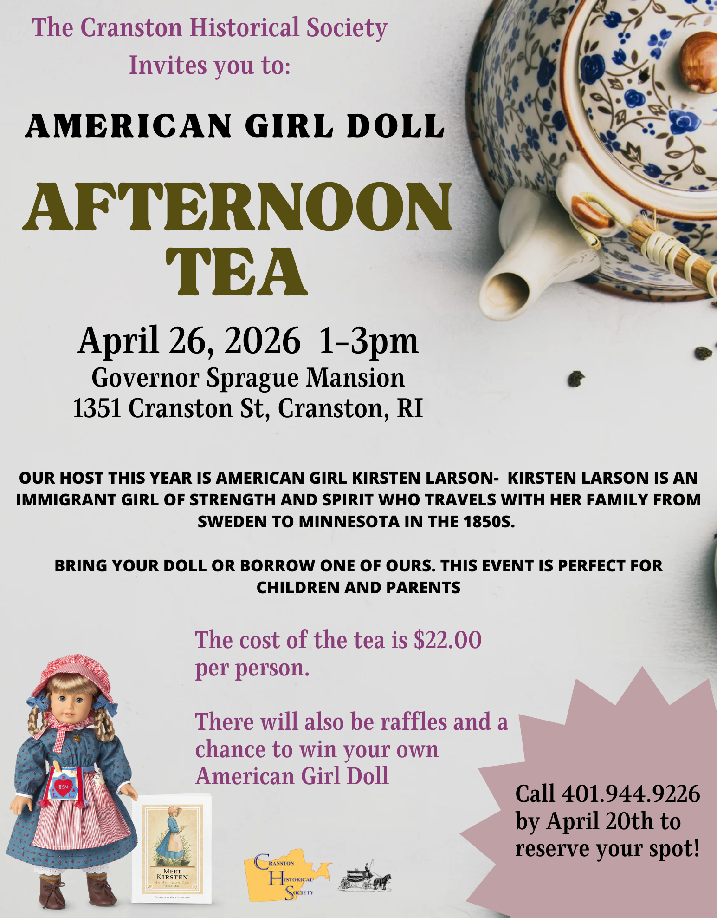

Payable: Cranston Historical Society, 1351 Cranston St., Cranston 02920
 _ _ _ _ _ _ _ _ _

Name:______________________________________________Phone:________________

Address/City/State/Zip:_____________________________________________________

# of Guests:______ Amount Enclosed: $_________ Ck #:_______

Email:_______________________________________

I am unable to attend--Here is a donation to support the fundraising event. $___________

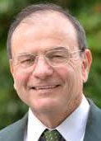
Calendar of Upcoming Events
April 21 7pm CHS Membership Meeting & Lecture. Special America 250th Lecture by author Gerald Carbone: Nathanael Greene: A Biography of the American Revolution. Come hear his story and meet the author.
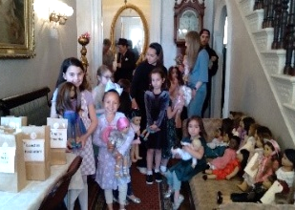
April 26 1 to 3pm American Girl Doll Afternoon Tea at Governor Sprague Mansion, Grand Ballroom. Young folks can bring an American Girl doll or favorite doll along with an adult. This year theme American Girl Doll: Kirsten Lawsen -- mid-1850. To reserve call 944-9226: $22 per person. Raffles and a chance to win your own American Girl Doll.
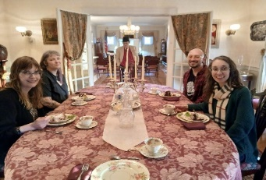
May 15 4pm Spring Early Evening Tour with Tea at Sprague Mansion Celebrate America 250th by enjoying a relaxing evening tea, sampling one of the teas (Chinese Bohea or Gunpowder) that the RI ladies burned in protest at Providence Market Square. You must RSVP due to limited seating. Call 944-9226. $22 nonmembers; $20 members, payable by May 9 to Cranston Historical Society, 1351 Cranston St., Cranston 02920. Accessible/parking in back.
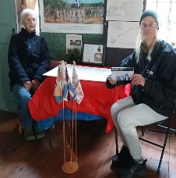
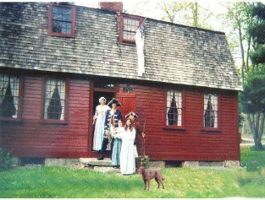
June 18 4pm Joy Homestead Colonial Family Day as part of Cranston America 250th Celebration. Pawtuxet Rangers will recreate a portion of Rochambeau’s march from Newport to Yorktown on the Washington Rochambeau Trail – stopping at Joy Homestead. Shuttle transports guests from Cranston Westparking lot to Joy, 156 Scituate Ave & back. Watch Facebook for festivity details.
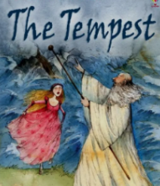
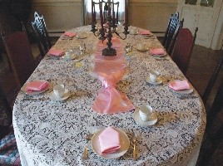
July 24 4pm Summer Early Evening Tour with Tea at Sprague Mansion Celebrate America 250th by enjoying a relaxing evening tea, sampling one of the teas (Chinese Bohea or Gunpowder) the RI ladies burned in British protest at Providence Market Square. You must RSVP due to limited seating. Call 944-9226. $22 nonmembers; $20 members, payable by July 19 to Cranston Historical Society, 1351 Cranston St., Cranston 02920.

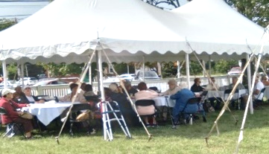
June 24 – 28 7:30pm Shakespeare Under the Stars returns at Sprague Mansion “The Tempest”-- by reservation. Possible Food Truck before showtime. Watch Facebook for contact info & how to reserve tickets. You can call or text Tracy 508-933-4233 / mamatracy2004@hotmail.com
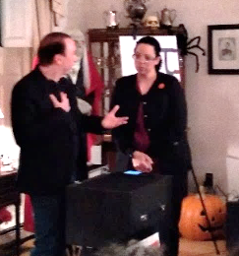
Aug. 25 5pm 2nd Annual A Taste of Cranston at the Gov. Sprague Mansion grounds. Sample a taste from some of Cranston’s finest restaurants! Watch Facebook for Ticket Info & Reservations. 944-9226.
October 23 Friday 7:00 pm at the Spoooooky Sprague Mansion. Charlie the Butler Ghost Party with Jared the Magician & Mentalist. Will Jared really read your mind? $20 payable by Oct. 19 to Cranston Historical Society, 1351 Cranston St., Cranston 02920. Light refreshments. A reader of fortunes is available for a separate fee. Age 14 & older.
Call to volunteer at any of our events (401) 944-9226

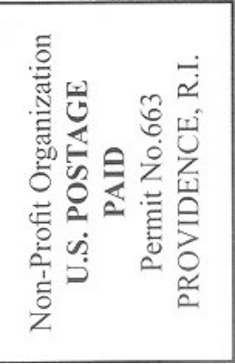

Inside:
- President’s Message
- Membership News
- Fall/Holidays Happenings
- The Liberty Tree
- RI’s Own Tea Party
- Cranston’s Own Revolutionary Fort
- Calendar of Upcoming Events

Cranston Historical Society
1351 Cranston Street
Cranston, RI 02920

